*** iFarmService Easy Instructions***

**iFarmService** is an easy to use job scheduling, costing and management system that was designed for the small and medium size farmer. It is rich in functionality and very reasonably priced. ($199 per year). The system was designed to accommodate the individual farmer, farm management companies and community based farmers.

Our objective is to keep it simple, elegant and cheap

**For Farmers** - Start with entering field records for crop plans, field preparation, scouting, farm jobs, scale tickets, equipment maintenance, sales contracts, shipments, invoices, restricted use chemicals and fertilizer applications. Generate simple enterprise statements to track profitability on a field-by-field and crop-by-crop basis.

**For Community** - Post available fresh produce and prices. Take orders on line or off line. Create recurring orders for community based customers. Develop the retail side of your business.

**For Connection** - iFarmService provides a farmers social network that is similar to Facebook. Post your ideas and questions. Comment on others posts. Build a powerful network that enhances your business

The system is an internet based application that can be used anywhere you have an internet connection. No software to install no data to manage. With the new lines of tablet computers you can enter field records in the field or view your profitability from wherever you are.

**iFarmService** provides a great starting point for anyone looking to improve their field records, crop yield and financial performance and gain a detailed understanding of their business. It's easy and powerful

**iFarmService** provides a farm based social network infrastructure. Aside from managing your own business the network will allow you to share ideas and thoughts with other farmers. As the network grows your access to information will grow. As you build relationships your ability to sell, share and exchange equipment, supplies, services and techniques will be enhanced.

**Easy Instruction** - We call the documentation “easy instruction” because it’s easy to read. Lot’s of pictures, not too many words and easy to understand. Not everything requires detail explanation. While rich in functionality the software is simple, elegant and easy to use.

We hope you enjoy it.

***Getting started***

Before we start there are a couple of tidbits of information that you need to understand.

* much of the information you will use is predefined in the “datatype” table.
* When you sign up as a user, a new datatype table is created for you.
* This can be viewed on the “Utility Menu” under data types.
  + Some information in “datatype” can NOT be changed because it is used for decision making in iFarmService. These items are flagged as “is protected”.
  + Other items can be customized by you to adapt to your situation.
* **For a list of Datatypes see Appendix A at end of documentation**

**Grids**

The grid components used in the system are clear, logical and consistent.

Most features of the system are entered through a grid view of that particular feature. Grids are loaded by adding new records. The grids are powerful and flexible. You can search and filter most components within a grid feature.

* You can sort most columns (by clicking on the header) and use the input boxes to filter particular columns. Some rows can be updated inline. (this is indicated by an asterick * next to the column heading. See feature documentation for the specific columns that are available to update.

A Grid example – for crop definition.

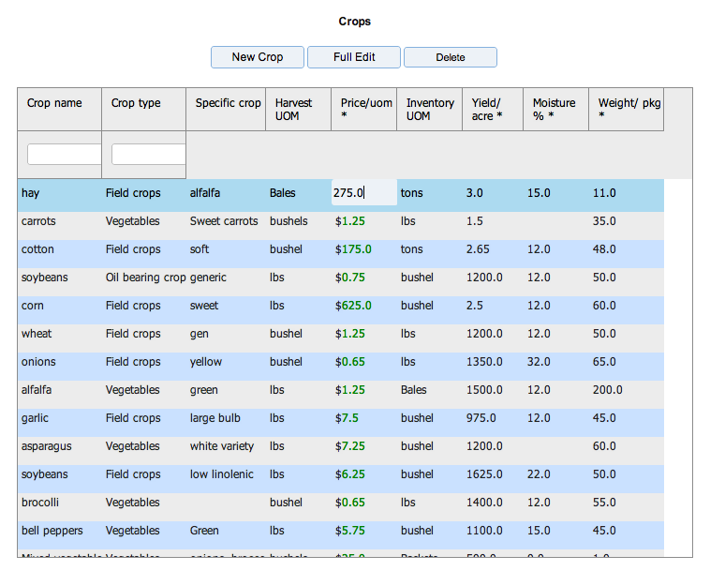

From most grids you have the options to

Add a new record

Edit an existing record

Delete a record

by selecting (clicking) the row and then clicking the relative button.

Some grids have specialized buttons based on the feautures needs.

Example – Purchase order detail grid has a ‘Receive PO line’ button.

**Dates**

All date entry fields will pop up a calendar when you click on the field. To insure correct date format you should use the calendar to select the date.

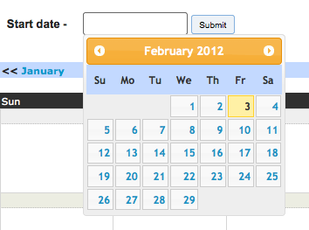

**Gravatar**

A gravatar is a picture that you post that will be used to identify you in the iFarmService Social network. Your gravatar will be used in social networking and assigned to all of your posts and comments. After you have registered you can go to ‘my Settings’ to access the gravator website. There you can upload your gravatar image and equate it to your user email address.

Not too much more to know for now. We’re about ready to get started.

**Let’s start here**

Enter this URL into your web browser.

[www.ifarmservice.com](http://www.ifarmservice.com)

then

Select the “get started with iFarmService” button to continue.



The first thing to do is to sign up as a user. You have a free 30 day trial. If you have a coupon code you can enter it to receive the first year subscription discount. Otherwise,

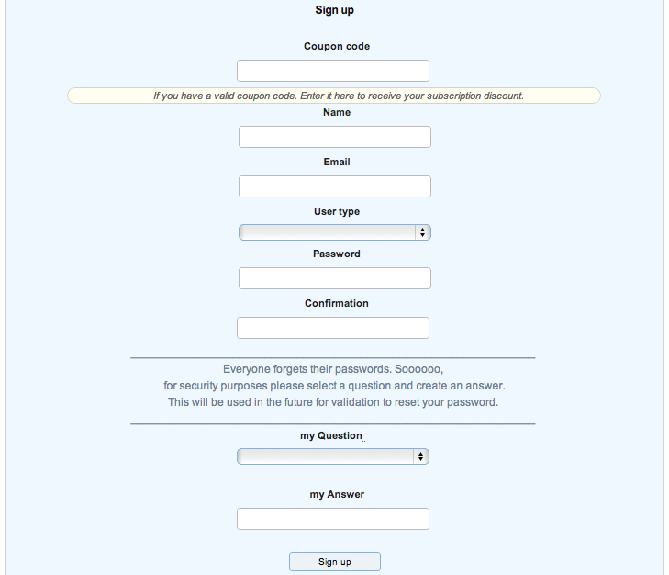

Enter your name, password and security questions and you will be established as a user. User type establishes the environment that you are presented with. In general, farmers and farm management types have the complete functionality. Crop customers have a reduced set that focuses on ordering fresh produce from local farmers and being part of the social network.

Once you are a user you have your own iFarmService account and can begin to define your farm business. This account will be valid for 30 days. In addition, you become an instant member of the iFarmService social network. Here you can share ideas and experiences with other farmers. When you are finished working you can log out. To “log in” after that just enter your email and password.

After that, if you wish to continue with iFarmService, you will need to purchase a subscription for $199 per year. You can manage your subscription status in the “mySettings” feature which is both on the header options and the “utilities” menu.

Once you have an account established you will just need to sign in , in the future, when you wish to use the system. The system is very secure and your data is protected based on current industry security techniques.

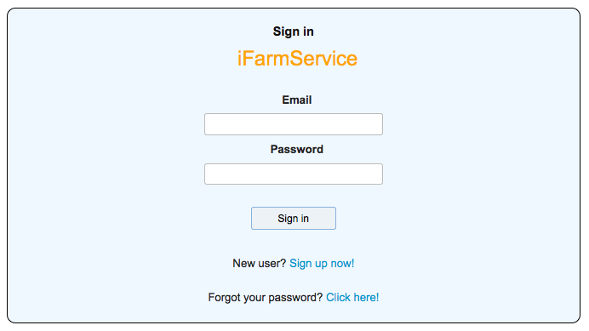

If, by chance, you forget your password you can change it by clicking on the ‘click here’ link and answering your security question. (Oh yeah! That’s why they asked me for a security question).

Now let’s get down to business.

All features can be accessed from the menu bar at the top of each page and the vertical menu on the left side of the page

(MENU BAR)

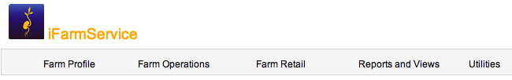

(VERTICAL MENU)

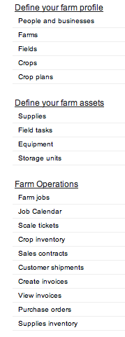

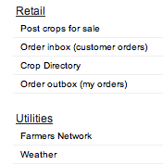

**Let’s farm. How to begin**

The first thing you have to do is to define your basic **profile information** which includes people, businesses, farms, fields, crops and crop plans. It’s a little bit of work and planning but once it’s done, the system is extremely easy to use.

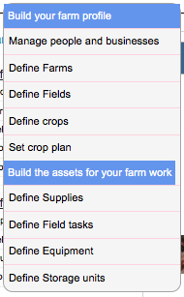

**Define People and businesses** (which we refer to as “parties”)

In party definition you define the name, address, email, phone and roles of the people and businesses that work for you and you do business with. For labor related parties you can define labor rates. For farm management businesses you can define the rate that you charge for labor. For customers you can define shipping addresses that differ from the billing address. Pretty simple.

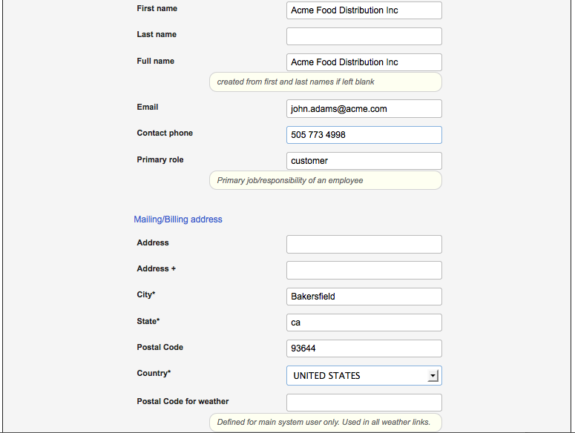

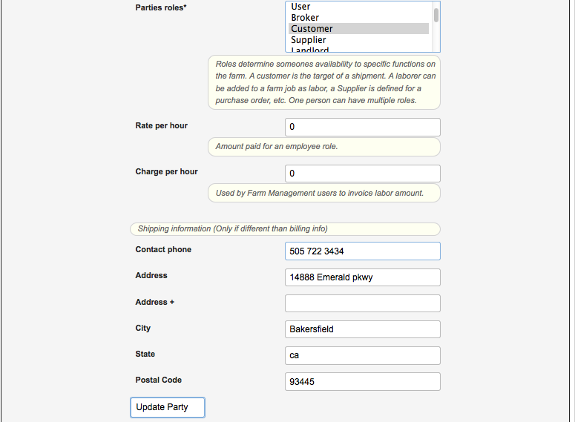

Enter a postal code for the area you wish to track weather in. A daily weather history will be tracked based on the weather postal code.

**Party roles** are IMPORTANT. They are used to expose your people and businesses in other parts of the application. A single party can have multiple roles.

***These are the roles that are used in the system.***

**User** - owner/user of the iFarm Service account . Is defined just after you register.  
**Employee** - people who are employed by the farm. (supervisor/foreman) will be exposed as labor for a farm job.   
**Labor machine** - people who operate farm machinery will be exposed as labor for a farm job.  
**Labor non machine** - people who perform basic work on the farm will be exposed as labor for a farm job.   
**Supplier** - business/person who supplies are purchased from are exposed on a purchase order.   
**Broker** - Sales agents are recorded on shipments for commission purposes.   
**Customer** – Business’ who harvested crops are sold and shipped to (in bulk) are exposed on shipments.

**Restaurant** - Business who orders current assorted fresh produce.

**Community**- People who join the fresh produce program. They are shipped assorted produce on some regular frequency.

**Landlord** - Land owner if fields are leased or share cropped is exposed in Field definition.  
**Client** - Farmers that a farm management enterprise provides service to are exposed in Field definition.   
**Billing source** - Assigned to each farm as the source for invoice billing information in Farm definition.  
**Test labs** - organizations that perform soil tests and crop quality tests. Defined in Field definition

**Define Farms**

Farm definition sets the base acreage for your farm. For farm management companies multiple farms can be defined. The billing source set s the remittance address for invoices.

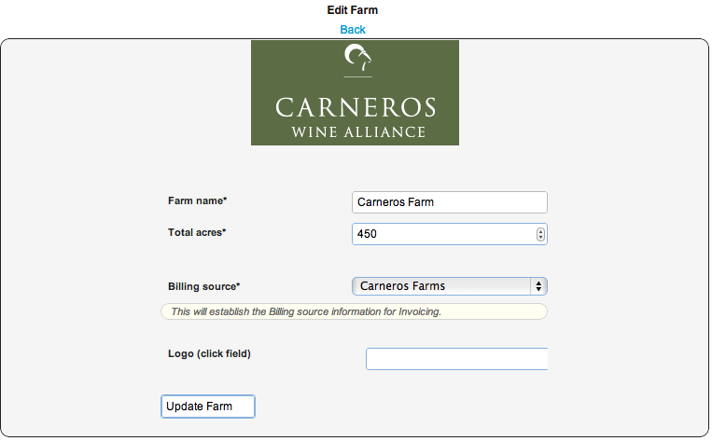

**Farm expenses** -

Belong to the farm. These will be used in your profitability reports for that farm. The initialize button will define the base set of expenses for the selected year/season.



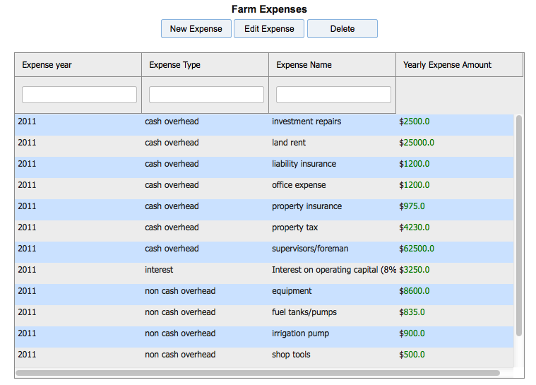

**Define Fields**

Fields define the specific characteristic's of the land being farmed. You can define unlimited fields for a farm. A field can be any size and is useful in understanding yield of specific areas. Within the field definition you can geocode your field location and then map the boundaries of the field. Farm jobs are assigned to specific fields. Scale tickets capture crop yield from specific fields.

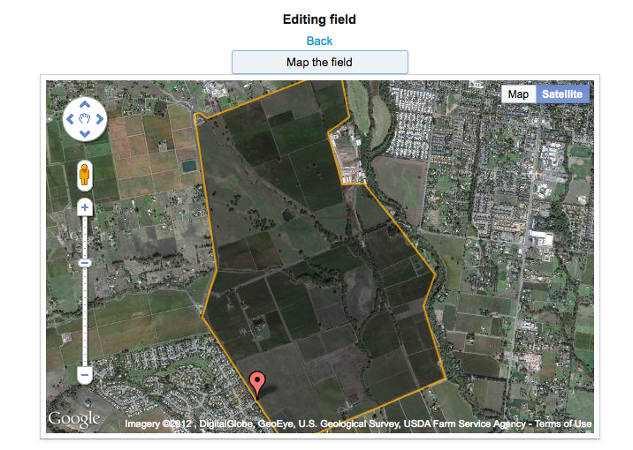

**Field Mapping**

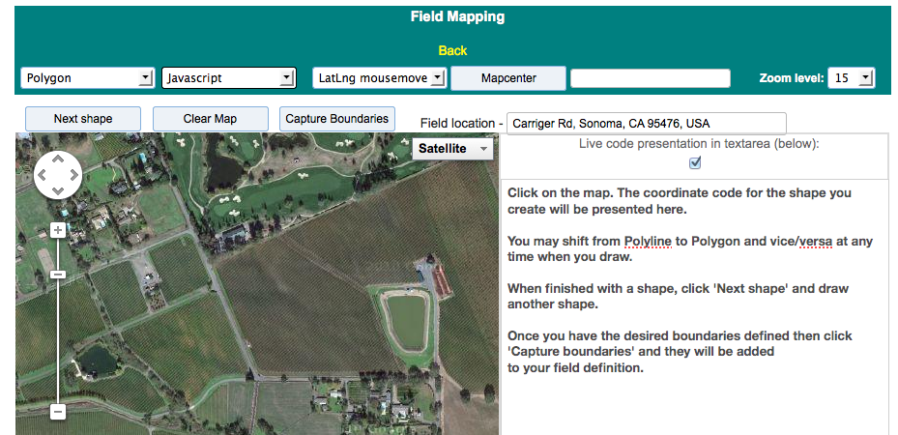

Your field location (map location) should be in proximity to the fields. From there you draw the boundaries as desired with the field mapping tool. A polygon will define a closed loop shape. Polylines allow you to draw any shape the you desire. Click ‘capture boundaries’ and the boundaries are then carried in to your field definition as shown above.

**Field information**

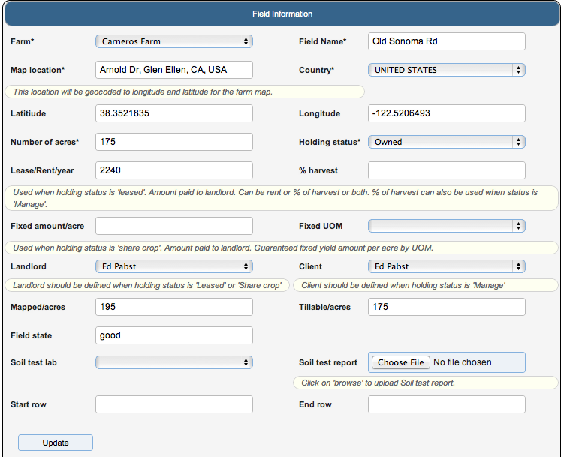

Fields belong to farms. You can assign as many fields as you wish to a farm. The finer your field definition is, the richer your crop yield information will be.

**Holding status** is important. It defines the management characteristics for the field.

**Owned** – the user is the owner of the field. Generally, means that you are an individual

farmer. If you have a mortgage for the land that would be entered as a rent expense for the

farm.

**Manage** - This states that the user is a farm management service and this is one field being managed. This is used to generate reports for farm management companies.

**Leased** – states that the user is leasing the field from a Landord . In this case, you may be paying rent and/or compensating the landlord with a fixed amount of crop per acre.

**Share Crop** – states that the landlord allows the tenant to use the field for a fixed percent of the overall harvest.

For holding status **‘Leased’** and **‘Share crop’** you must define the landlord in party definition and select them for this field.

For holding status **‘Manage’** you must define the client in party definition and select them for this field.

You can also maintain digital copies of the soil reports for the field by uploading the specific report and assigning it to the field.

**Define Crops**

You can define as many crops as you like. Crops can be co-mingled by field.

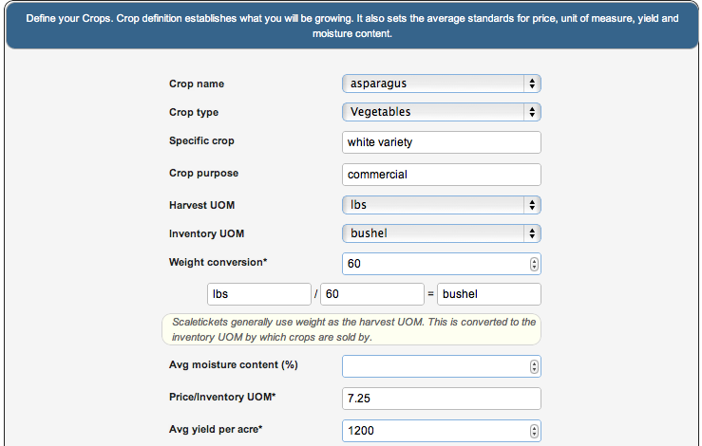

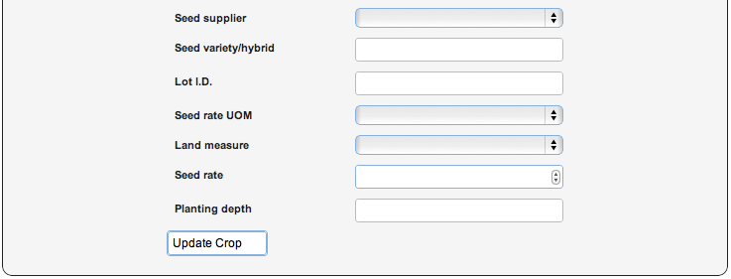

Harvest unit of measure establishes the estimated unit that will be used during harvest to capture yield. Normally, this will be weight but is not restricted to lbs. It could be defined as tons, kilos or even eaches. The inventory unit of measure establishes what unit inventory will be stored and sold in. The weight conversion converts the harvest UOM to the inventory UOM.

Price is for the inventory unit of measure. This is used on shipments and for invoicing purposes if no contract price is established.

Average yield per acre is the historical or industry standard for a specific crop yield. It is the target to measure your crop yield against.

Most other fields are informational for the specific crop.

** **Community based farming** – You can define crops and crop plans that represent customer packs of variety crops. These can be recorded as inventory with scale tickets and then shipped and invoiced.

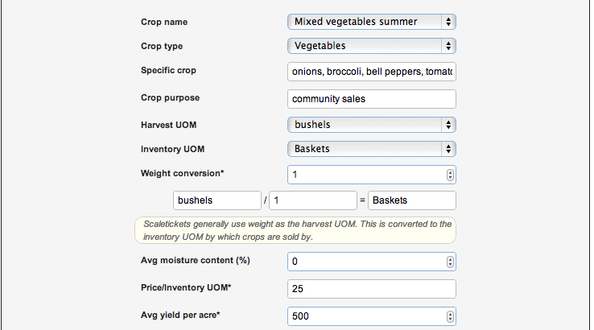

**Define Crop Plan**

A crop plan establishes your intention of growing a particular crop for a season/year.

Crop plans are entered into farm jobs to gather costs and are harvested through scale tickets to establish yield and inventory.

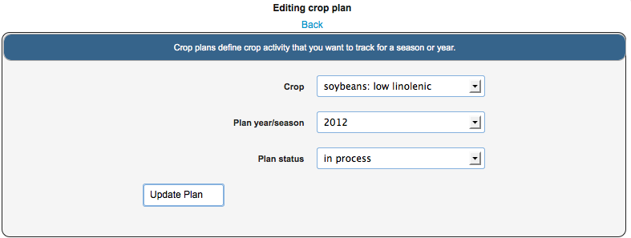

For a crop plan initiative you assign the fields that will be planted. You set the total acreage by field and can assign an estimated yield by field. Farm jobs and Scale tickets will validate the crop/field entry against this.

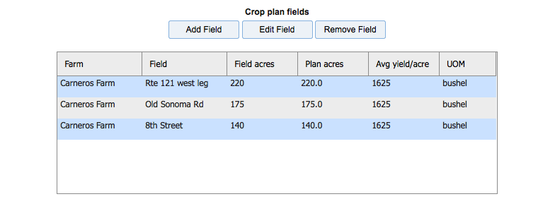

That pretty much completes our farm profile definition. Next, we move on to defining the assets that will be used in Farm jobs.

**Building the Assets for your Farm Work**

Assets are the components that are used to build a farm job. They will establish a job cost basis for labor, supplies and equipment.

Assets include Field tasks (work), supplies, equipment and storage units.

They additionally include Labor which was previously discussed in Party definition.

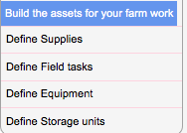

**Define Supplies**

Supplies are the components used in farm jobs. They are defined with a usage rate per acre that will generate an overall estimated cost based on the acreage of the farm job. The purchase unit of measure is converted to an inventory unit of measure based on a conversion factor. EPA id is used to identify restricted use chemicals. If you assign a supply a type of ‘restricted use’ then these are tracked in farm jobs for compliance reporting. We allow you to track supply inventory.

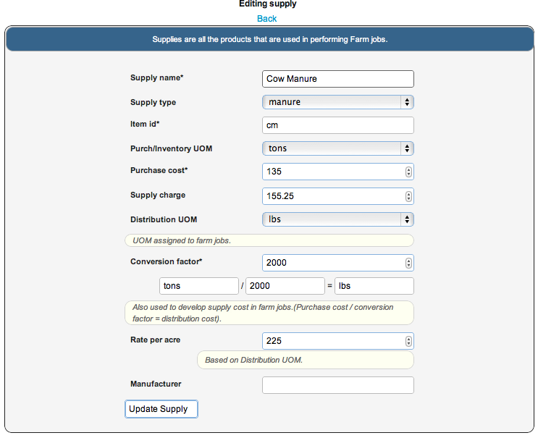

By selecting a **supply type** of ‘Fertilizer’ you will presented with additional information about the fertilizer. By entering a ‘planned’ farm job that uses this fertilizer you can view the usage and nutrient content for the job.

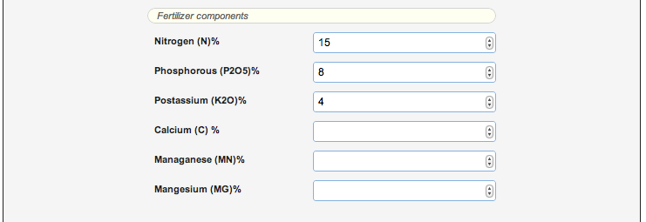

By selecting a supply type of ‘Restricted use chemicals’ you will be presented with additional information that supports EPA reporting requirements.

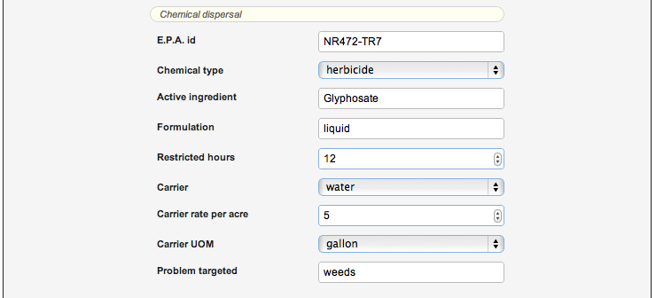

**Define Field Tasks - (field tasks identify specific work)**

When you register as a new user we establish a base set of field tasks. You can use them, change them or delete them. Just trying to help you get up and started quickly.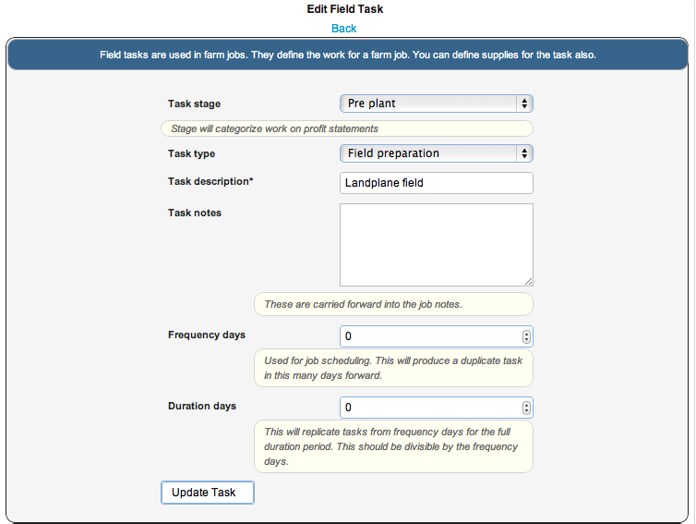

In addition, you can define the supplies that will be used in a field task. These will be carried into the farm job when the task is assigned to the job. The Qty/acre amount will be extended by the acres on a job to develop the supply cost.

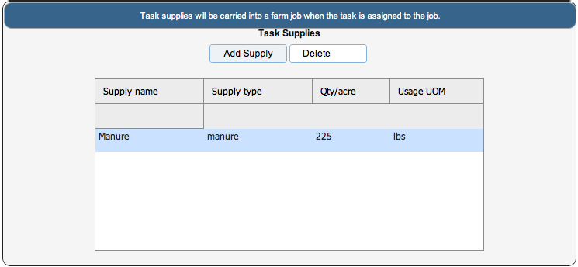

**Define Equipment**

Equipment is the machinery (capital assets) that are used in a farm job. You can enter the information that will be used to develop a depreciation schedule and cost of ownership. By identifying your yearly usage hours the system will develop an hourly usage cost that will be used in the farm jobs to develop an equipment cost for the job. For Farm management you can specify a charge rate for the equipment. You can also upload images of the equipment.

If you define a fuel type and a usage rate per hour then when this piece of equipment is assigned to a farm job the fuel usage will be calculated and added as a supply cost to the farm job.

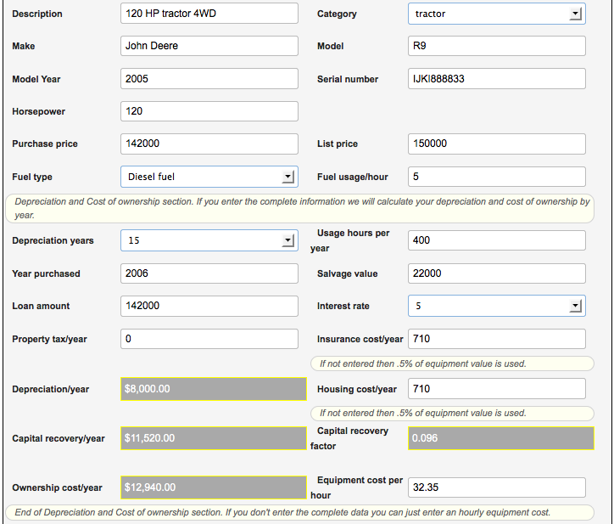

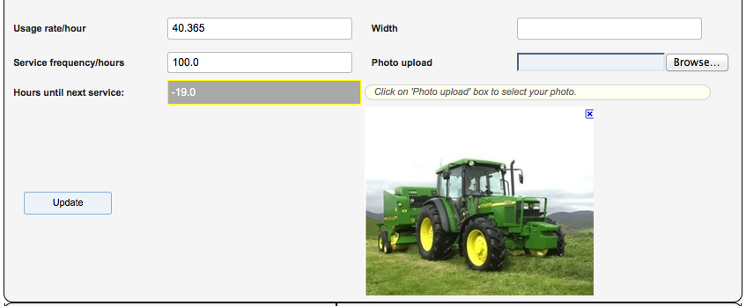

In addition, you can view the farm job activity history of the equipment and track the maintenance activity. By establishing a service frequency period you will always know how many hours until the next required service or by how many hours you have bypassed the service period.

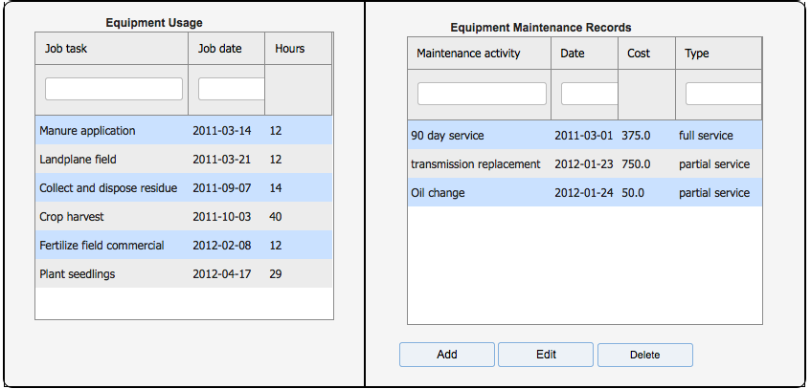

**Define storage units**

Storage units are defined as either physical or logical areas where both supply and crop inventory can be located. By assigning a ‘Supplies default storage’ all purchase order receipts will be directed to this location.

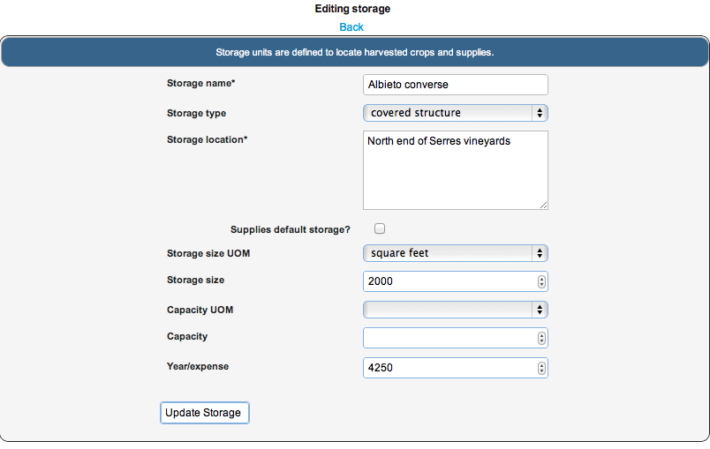

Well that’s it for defining your job assets. Next we move on to the operational features of running a farm.

**Farm Operations**

Farm operations are all the features used to run the farm. With them you can schedule, plan, execute and monitor the workings of the farm. You can build a complete seasonal plan with Farmjobs. By this we mean that you can define jobs in a “plan” status . All features allow selection by job status. As you are ready to execute jobs you can set them to an “in process” status and print the job sheet. When the job sheet is complete you can enter the actual activity and set the job status to “complete”.

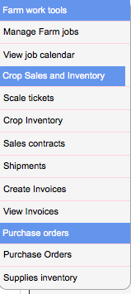

**Farm jobs**

Farm jobs define the various work tasks and costs for running your farm. They specify the specific work, field and crop plan associated with the job. Farm jobs have three status’.

Plan

In Process

Job Complete

After a job’s status is set to ‘Job Complete’, a final cost is developed and the job can no longer be changed.

This is very useful for planning your season. You can, basically, define all the work and costs associated with what “you know”. By using the estimated yields in your crop definition you can run “pro forma” profitability statements before the season has begun. When you know the actual work performed you can enter it against the planned tasks and monitor your projected profitability.

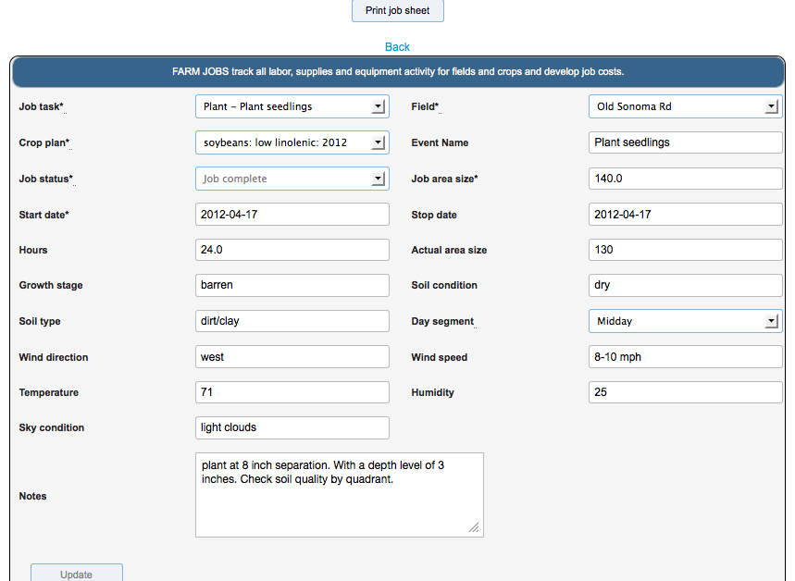

The farm job is linked to a calendar event. The event name is used in the calendar.

The area size for the job drives the cost development for associated supplies.

The actual area worked is used for final costing.

The job hours drive the cost development for labor and equipment.

The start and stop dates set the job dates in the calendar.

Any cost data from supplies, labor and equipment can be overridden in the cost grids

In addition, if the job task has an associated frequency interval then the specific farm job can be replicated when the job is first defined. In that case, if supplies were also defined for the job task then they too would be replicated with the new jobs.

This is useful when you have repetitive tasks like weekly irrigation that you want to develop costs for.

An effective process for farm jobs is to define the job and when you are ready to execute the job then set the status to ‘in process’ and print the job sheet. Whoever manages the work can record the actual events that occurred and supplies that were used. The job sheet can be used as an input form to complete the farm job.

**Farm job costs**

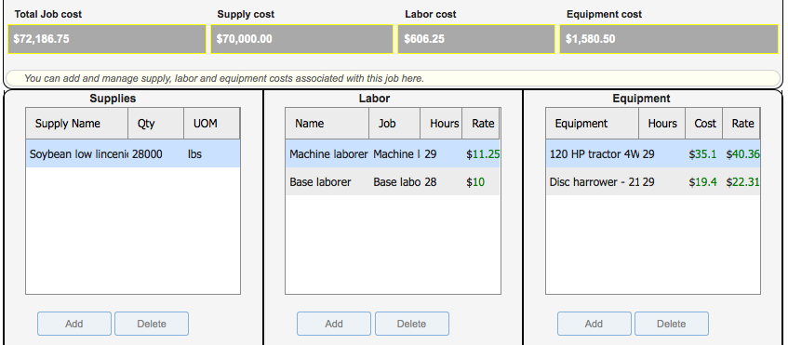

You can define the supplies, labor and equipment for the job. The specific costs may be entered directly or they can be carried in the from the supply, labor and equipment definitions

**Supplies** – have a cost and usage qty per acre that is extended by the job area size.

**Labor** - Party definition contains labor rates that are extended by job hours.

**Equipment** – has a usage cost that is extended by job hours. If you define a piece of equipment to use fuel and set a usage rate per hour then the appropriate fuel supply will be added to the job.

Any of these values can be overridden. Overrides can occur inline in the grids.

Assignment of specific equipment to **completed jobs** records that usage activity for maintenance schedules.

See next page for an example of the Job Sheet.

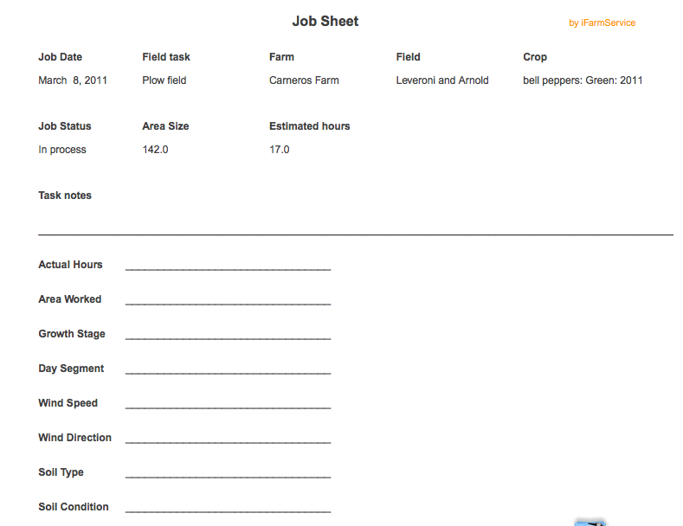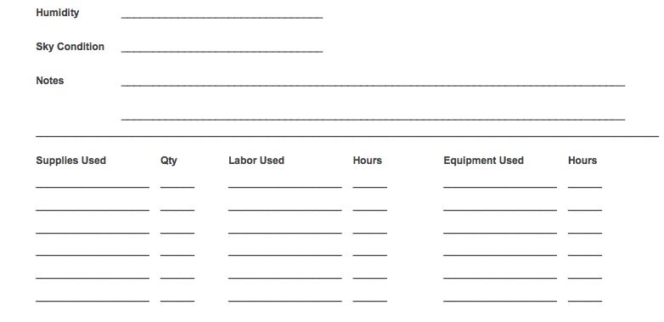

**Job Calendar**

The job calendar allows you to view your work schedule from an orderly, clear and concise calendar view. The job can be selected and maintained from the calendar just by clicking on the job. The changes you make will be reflected in the calendar. By putting the cursor over the job a full job description is presented. The color codes represent different job status’.

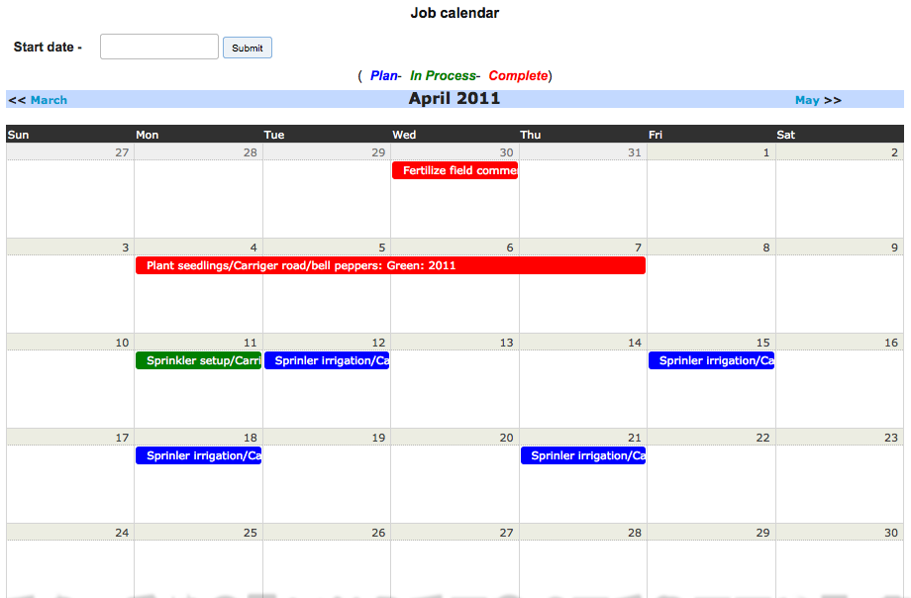

**Scale tickets**

Scale tickets record the weight and/or units of the harvested crops. A scale ticket creates an inventory record at a specific storage location. You can choose to record inventory in a consolidated fashion (by grade) or you can maintain scale ticket integrity in inventory. This is useful when you want to ship the full scaleticket to a customer.

Additionally, this feature can be used to record the number of customer packs for **community based farmers**. Once, the pack is created in inventory, it can be shipped and invoiced.

Scale tickets were designed for repetitive rapid entry. When entering scale tickets you first set ticket defaults. After the defaults are set then you just enter the weight or count information repetitively. Each scale ticket will inherit the defined defaults. You can override the defaults for a specific scale ticket if you wish.

If you wish to restart the defaults return to the ‘add scale ticket’ button.

The field or fields that the harvested crop originated from is recorded. This allows for traceability.

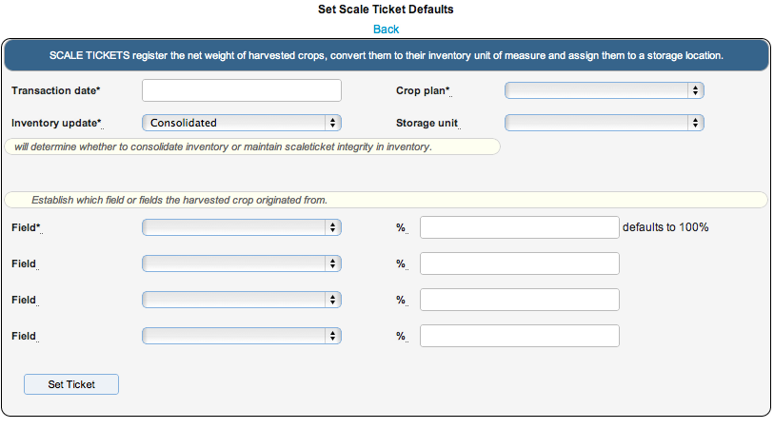

Crop definition contains unit of measures for harvest amounts and inventory (sales) amounts. The harvest amount, usually weight, is converted to the inventory measure based on a weight conversion in crop definition.

When you enter gross weight/unit and Tare weight the Net weight is automatically calculated and automatically converted to inventory qty.

Inventory amount is directed to a storage location. Moisture % is recorded for certain crops. The inventory grade can be established here or can be changed in the inventory records.

Inventory can be recorded by scale ticket or consolidated for that crop, grade and storage location. This is useful is you wish to ship a scale ticket.

You can continue to enter scale tickets, one after the other. When complete just hit the back button.

**Scale ticket entry form**

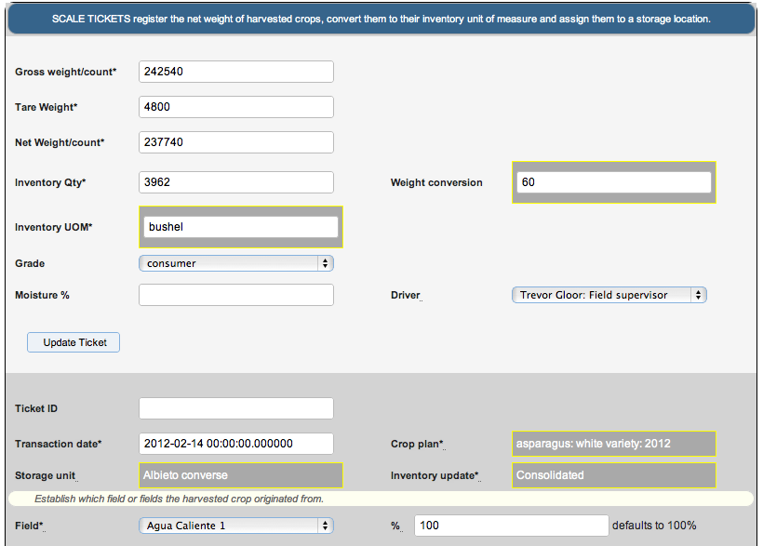

The defaults can be changed as desired. After the scale ticket is created and the inventory has been updated, you can only change ticket id and the field information.

**Crop inventory**

Crop inventory is created from scale tickets. Inventory is recorded by location and grade. Inventory can be further defined by the specific scale ticket. If inventory was created by the scale ticket then it will be referenced as a separate item.

Inventory can be re-graded and transferred between locations. Locations can be defined for damage or any other purpose for inventory re-categorization.

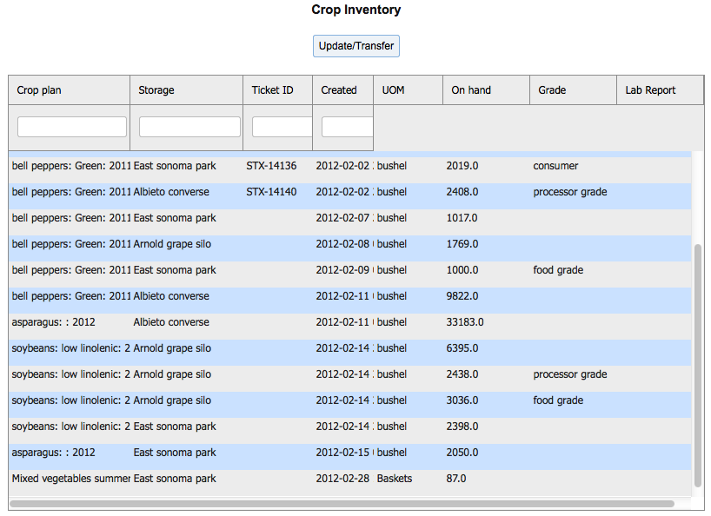

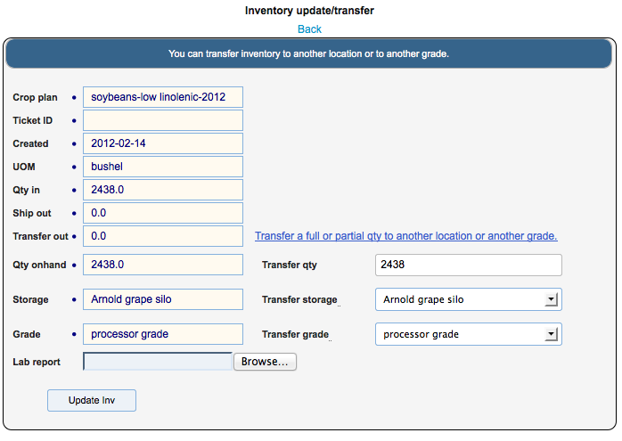

Inventory can be viewed in detail.

**Qty in** – from scale ticket or transfer from another location

**Ship out**- quantity assigned to a customer shipment

**Transfer out** – quantity moved to another location or grade

**Qty on hand** – quantity currently available in that location

You can transfer and/or re-grade inventory. If you leave the transfer qty the same and change the transfer storage location and/or the transfer grade, the inventory will be moved accordingly. If you change the transfer qty (only less than onhand) the partial qty will be moved accordingly and the remainder will remain in the existing inventory record.

You can also store any digital lab reports along with the inventory records.

**Sales Contracts**

A sales contract is an agreement with a customer to reserve crop inventory and sell it in the future (at harvest) at a specific price. When a shipment is made, the contract can be referenced and the contract price will be used on the shipment and for invoicing.

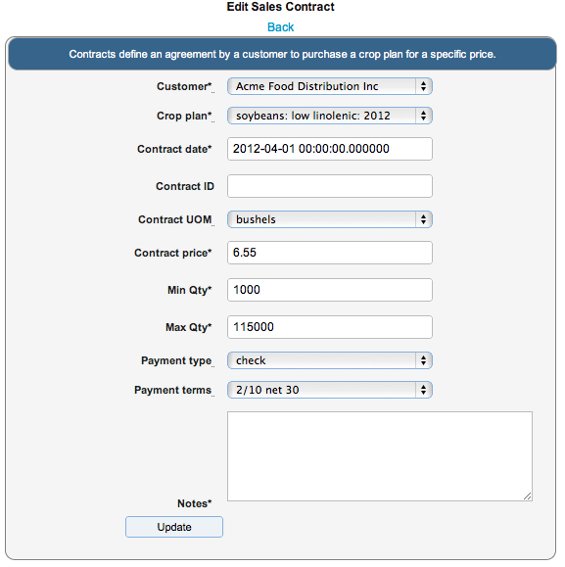

**Shipments**

A shipment is a sale of inventory to a customer. It can originate from a sales contract or just be direct to a customer.

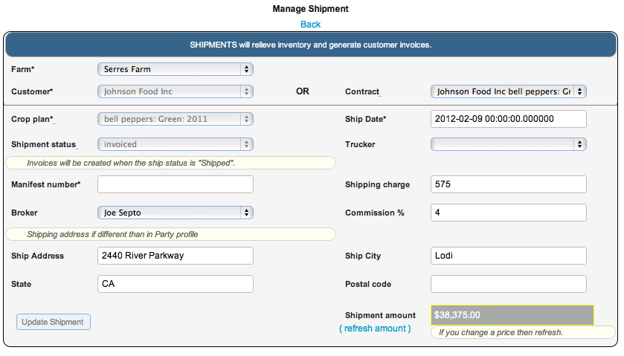

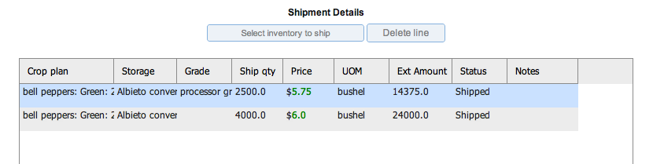

Price is captured either from the contract or the established crop price in crop definition. Price can be overridden in the shipment detail grid. Shipment status can be defined as either new or shipped.

If the shipment is flagged as shipped it becomes eligible for invoicing. When the shipment has been invoiced the status is set to ‘invoiced’ and the shipment can no longer be changed.

A shipping charge can be assessed to the customer and will be invoiced. A sales agent (broker) and his commission rate can be defined. An alternate shipping address can be defined.

**Shipping Crop Inventory**

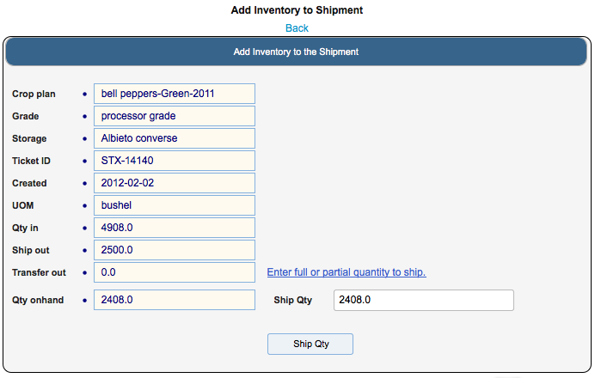

**Invoices**

Invoicing is a two step process. First you must generate the invoices and second you must print them. Invoice generation will look for all shipments whose status is ‘shipped’, create the invoice from the shipment information and then flag the shipment as ‘invoiced. When the invoice is created it’s status will be set to ‘new’. You can run the process for a specific customer and/or shipped date range.

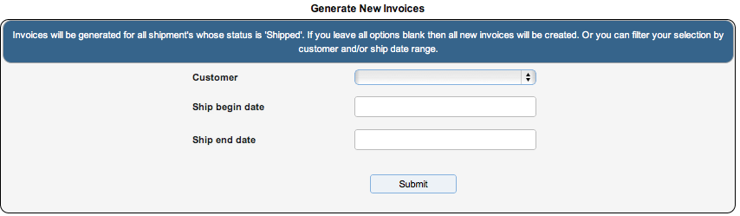

You can view the invoices using the ‘view invoice’ option on the farm operations menu. You can select an invoice and change any information other than financial and product information. I

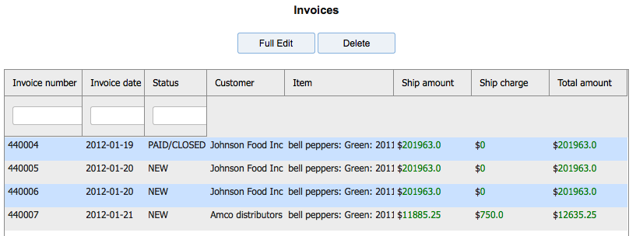

**Print Invoices**

You can filter the print of invoices by customer and date range. You can print a single invoice by number. Or, you can reprint invoices when you want. Invoice print will look for all invoices whose status is ‘new’. When you print an invoice it’s status is set to ‘printed’. If you set the reprint option to ‘yes’ then the process will only look for invoices whose status is NOT ‘new’.

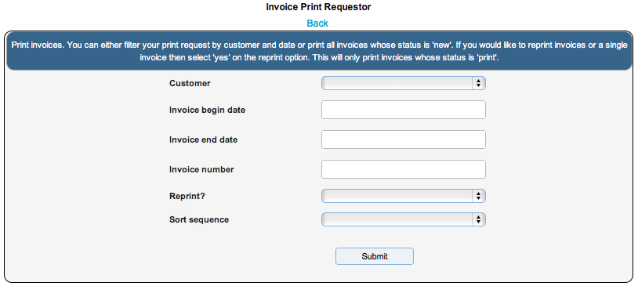

Below is an example of a printed invoice.

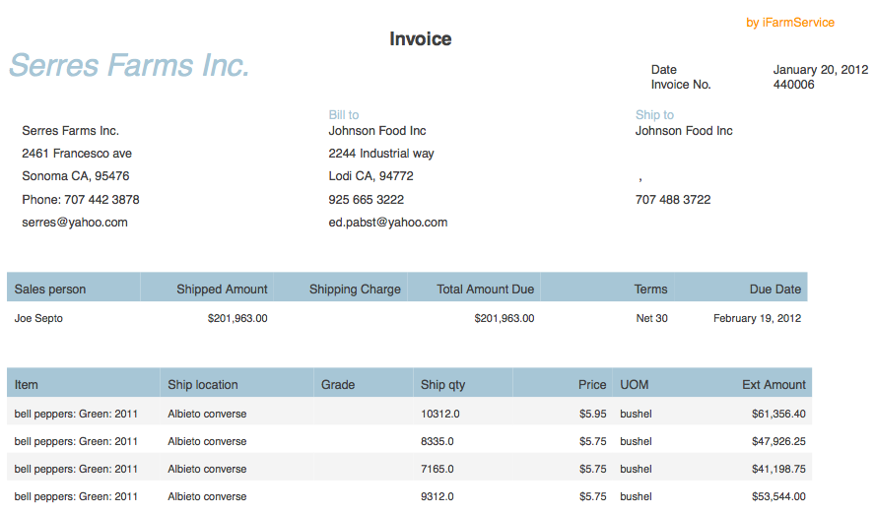

**Purchase orders**

Purchase orders are used to acquire your supplies inventory. They are written to a defined supplier (from party definition). For the line items, the supply cost and unit of measure is taken from the supply definition but can be overridden when the PO line is created.

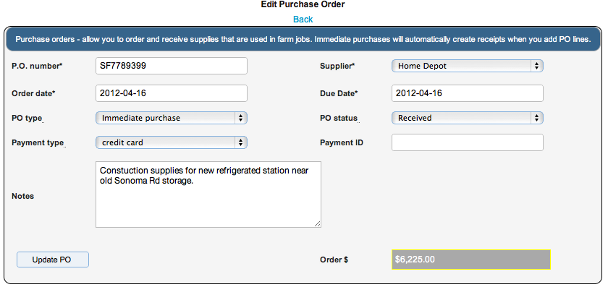

If you set the PO type to ‘immediate’ and set the PO status to ‘received’ the line items will be received into inventory as they are added. This is a convenient way to establish your supplies inventory as a starting point or if you are adding a PO after the fact. Otherwise, as is the case with a ‘pre purchase’ PO you select to receive the lines items at a later time by clicking the Receive line button.

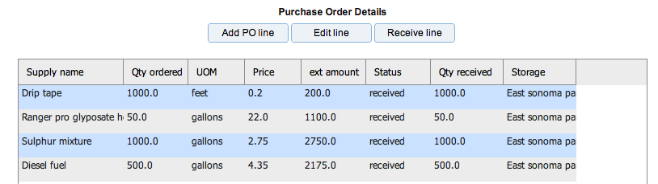

**Add/edit a PO line**

Select the desired supply from your supply list. Enter the quantity desired. Purchase unit of measure is always taken from the supply definition. Price can be entered or will be taken from the supply definition.

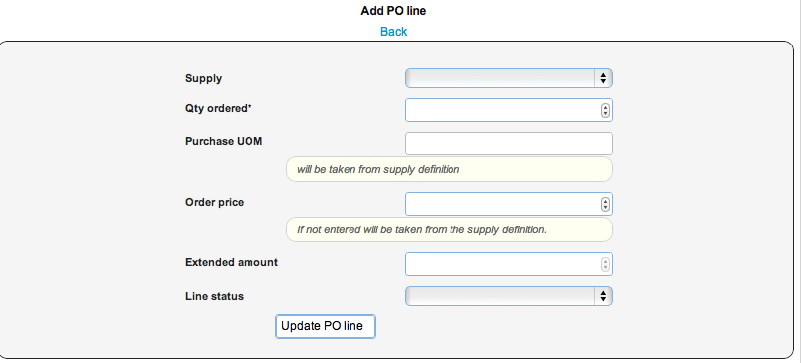

**Purchase receipt**

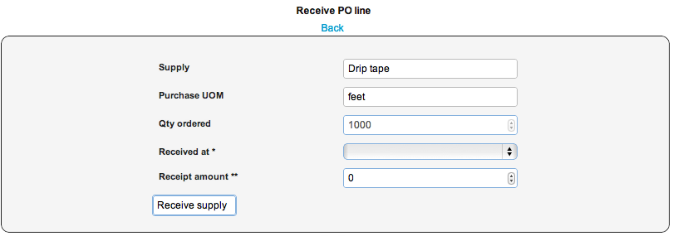

Enter the quantity received. You can have multiple receipts for a line. Also, enter the storage location where the supplies will be located. A receipt will create a supply inventory record in the storage location.

**Supply inventory**

Supply inventory records are created when you receive a purchase order line. The lines are received into storage locations. For each supply/storage location, we maintain an inventory value and an average cost for the supply.

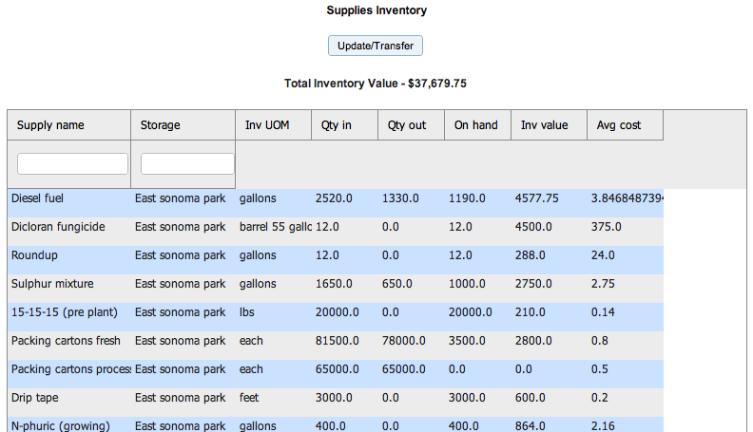

You can transfer and adjust your supply inventory . You can transfer all or part to another storage location. Or you can adjust the inventory for your needs. Qty in shows the PO receipt amounts and positive quantity adjustments. Qty out reflects, supply usage, transfers and negative adjustments. On hand reflects the current inventory balance in that location. Supply inventory is relieved when a farm job, that used that supply, is completed

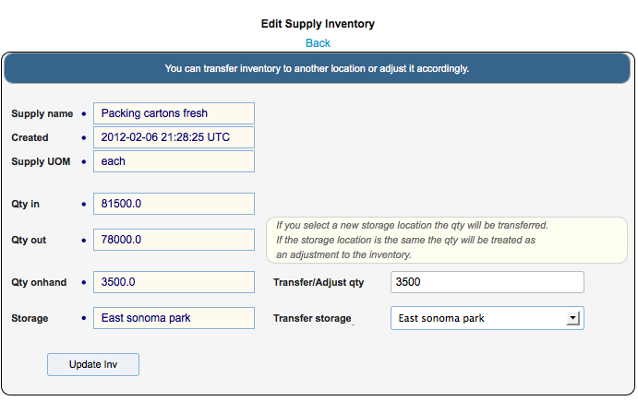

**Retail**

The retail component of the system supports the local farmer and consumer relationship. Farmers can post their fresh produce to the “Crop Directory” which becomes visible to all “Crop Customers”.

Customer can order the produce on line and have the order accepted by the farmer. The various logistics are supported by notification in the Crop directory of either ‘ship days’ or ‘pickup days’ as defined by the farm.

The crop directory supports: availability dating, pricing by different units of measure and shipping charges where applicable. Additionally, notes can be posted for further information dissemination about the particular crop offering. A crop will remain in the directory while it’s status is ‘active’.

Orders are created by the customer. They can work on orders that are in status ‘new’. To make them visible to the farm the status is changed to ‘submitted’. When the farmer accepts the order the status is changed to ‘accepted’. At this point no more changes can be made to the order. Other status changes after that are informational for the customer.

Retail functions for the farmer

Post crops to Crop directory

Manage order inbox

Retail functions for the customer

View Crop Directory

Create and Manage orders

**Crop Directory**

Presents all available crop that have been posted by farmers. You can filter the list for a specific city and state and/or crop.

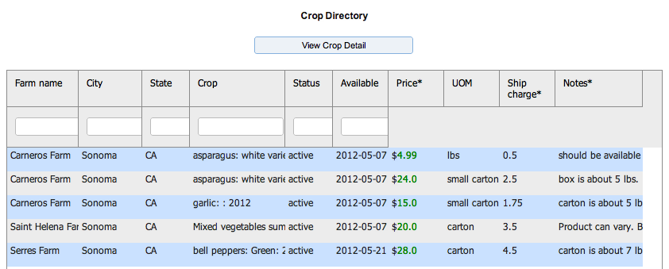

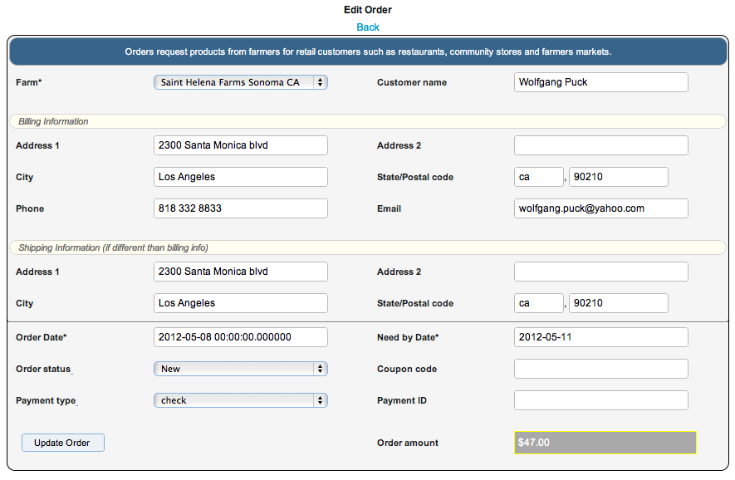

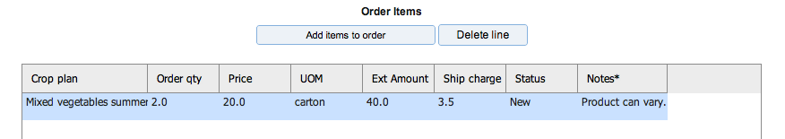

**Reports**

The system comes with various reports to help you manage your farm. The current report list contains

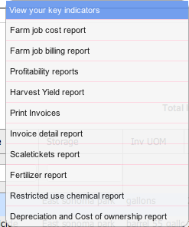

**Farm job report** – which assists is monitoring the status and cost of the work occurring on the farm. You can filter the report in several ways. You always enter a date range for the work. Additionally you can sort the data in the report by

Crop, Field, Task, Job Status, Date

Job status is useful when you are maintaining your data for planning purposes. You can select for planned tasks or completed tasks exclusively. Or, view all status’.

**Requestor**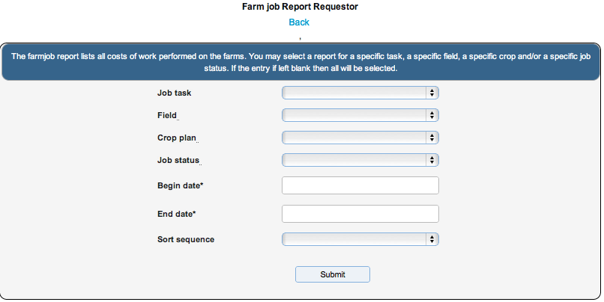

**Report**

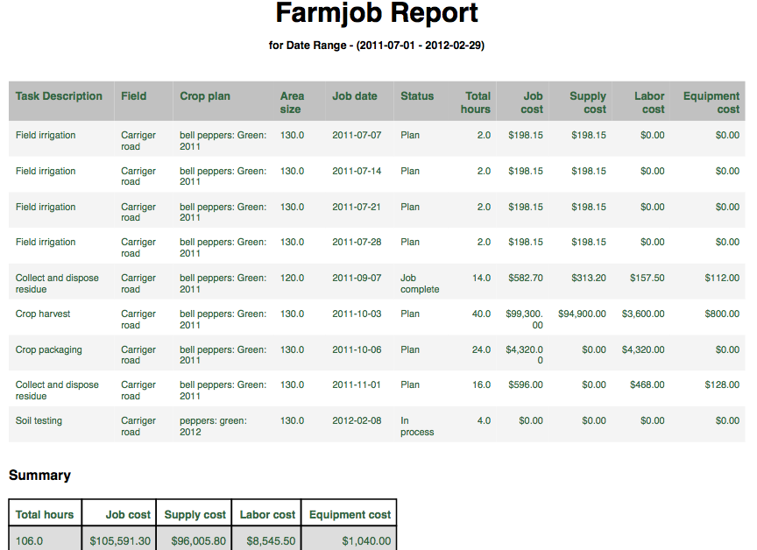

**Profitability reports** – which come in a couple of flavors

**Cost analysis**

**Profitability analysis**

These are all selected through a single requestor for “Profitability Reports”

As with the Jobs report the requestor gives you a lot a flexibility.

**Requestor**

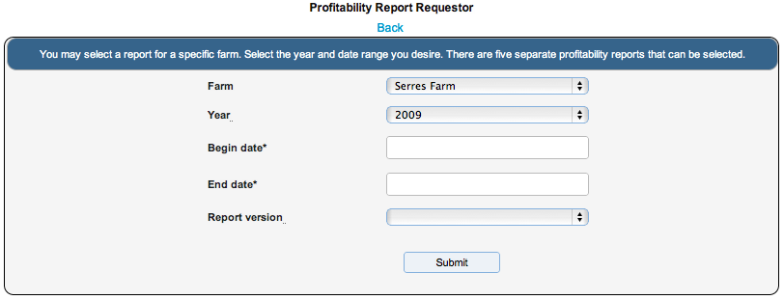

You must select the farm and plan year to produce your report. You must always enter a date range of activity. Then select the specific report version.

**Cost Analysis**

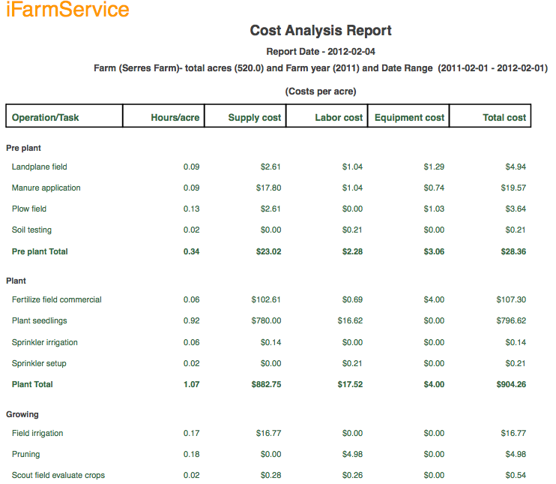

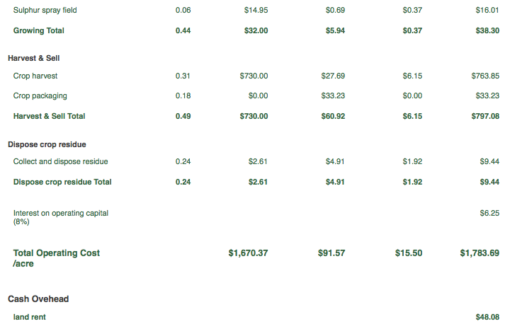

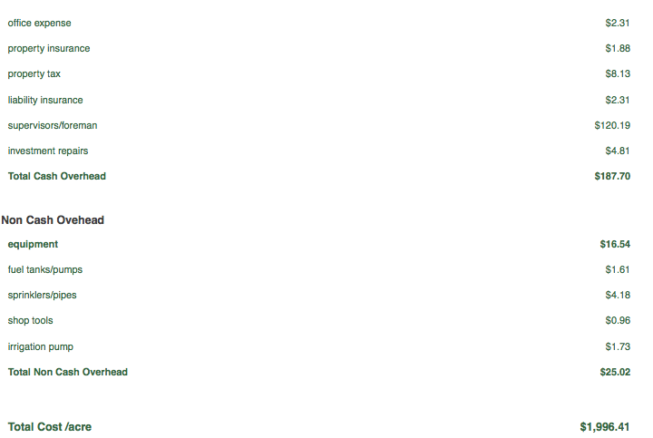

**Profitability Analysis**

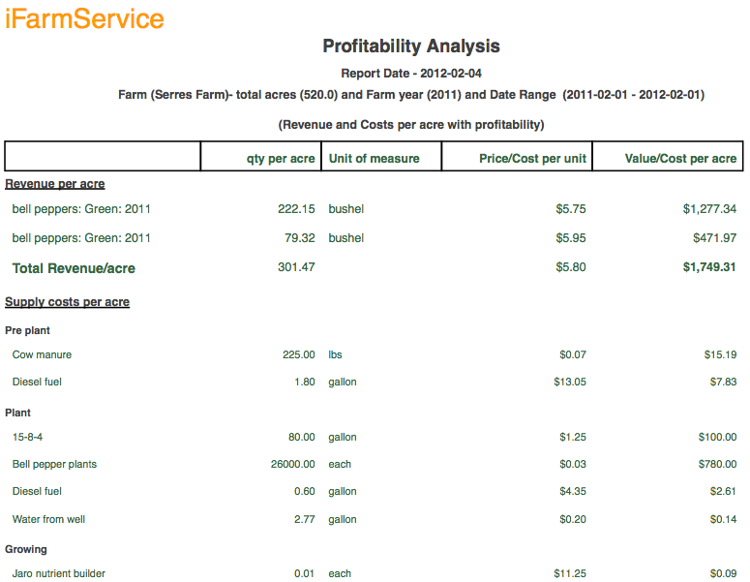

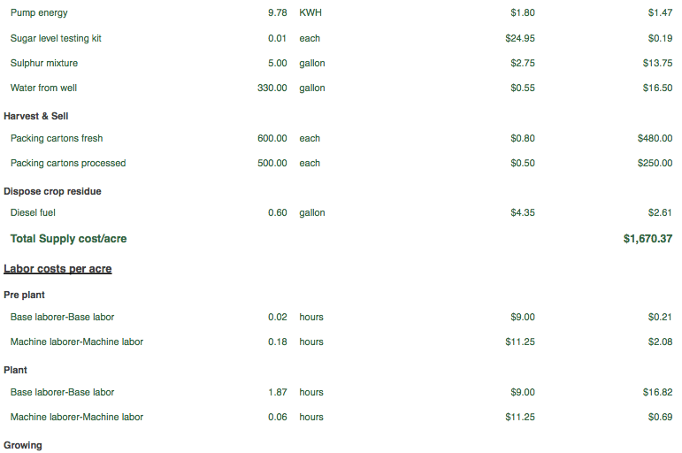

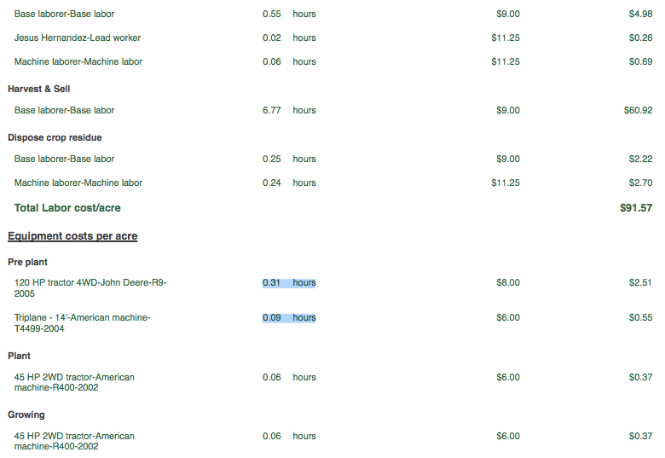

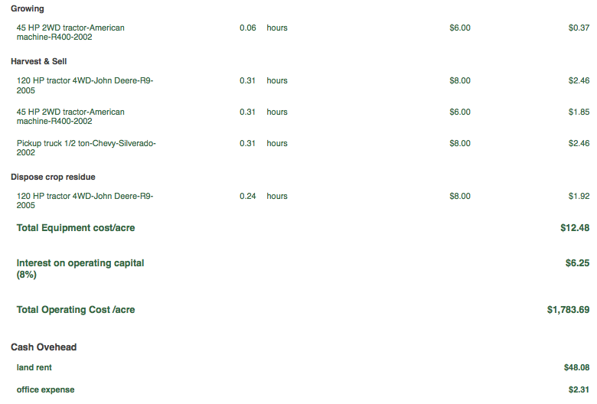



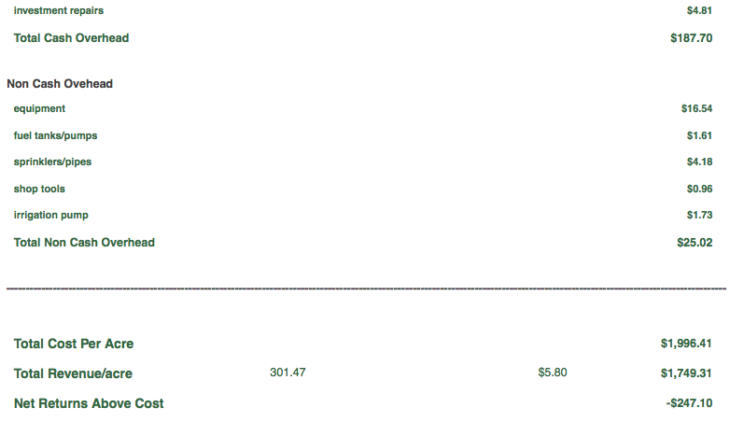

**Harvest Yield Report**

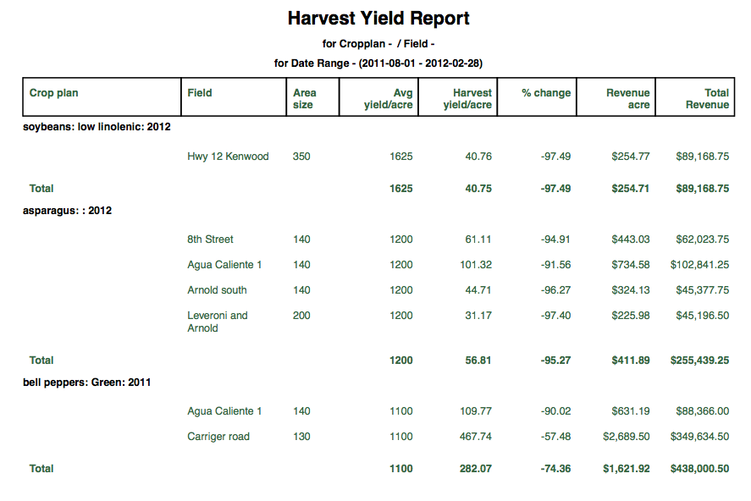

**Invoice Detail Report**

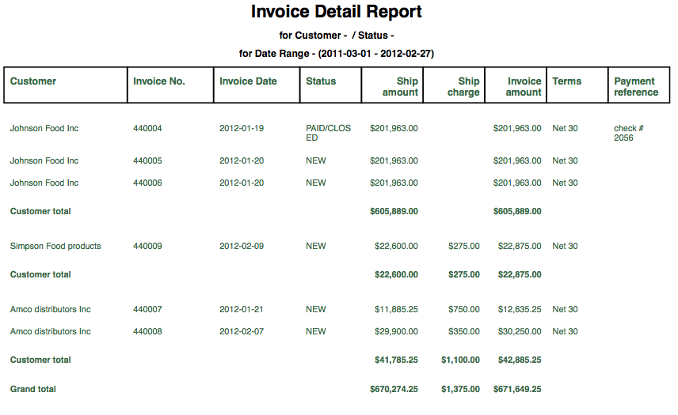

**Scaleticket Report**

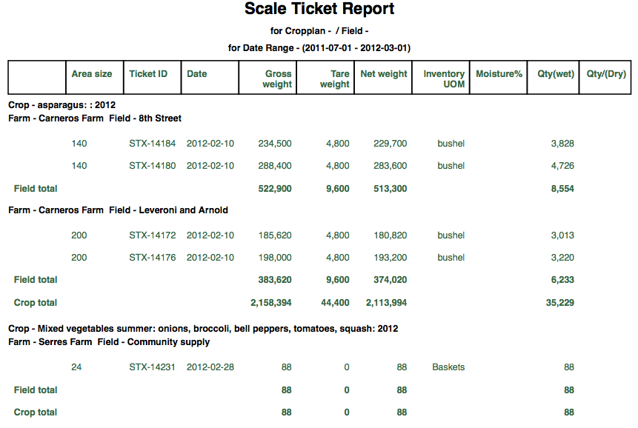

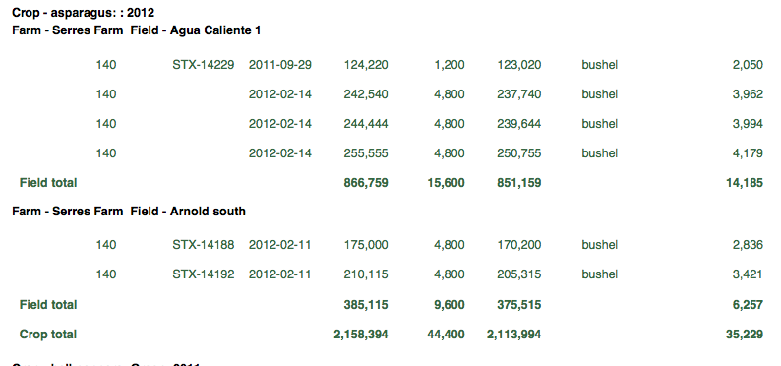

**Fertilizer Report**

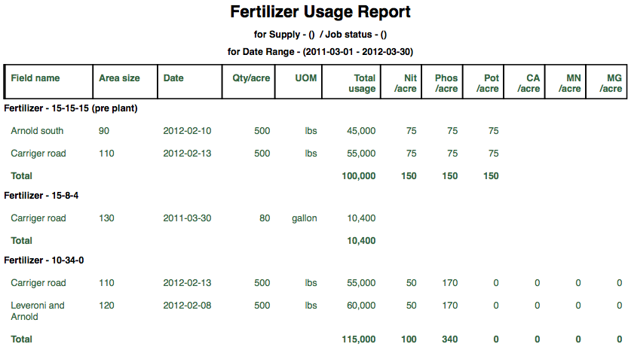

**Restricted Use Chemical Report**

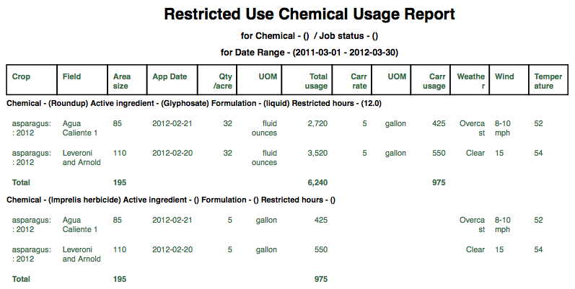

**Farm Social network**

The iFarmService social network allows all registered users (farmers) to exchange thoughts, ideas, images, inspiration and business information. Each farmer can post any information they wish and it becomes visible to other farmers. A farmer can then select specific farmers to join their community which will weave a continuous idea and information flow for your personal community.

**Farm community**

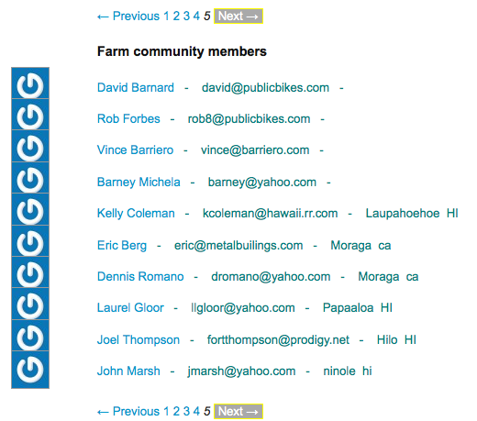

When you view the farm community you can select an individual farmer, click on their name, and view all of there comments. If you like what they have to say you click the “Follow” button and they will be come part of your personal community.

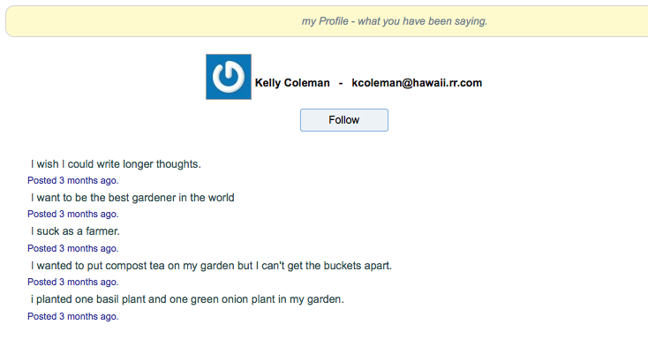

**My community**

You have a ‘My Community’ page. . Here you can post your personal comments and you can see all of your comments interwoven by date and time with the comments of other farmers that you “Follow”.

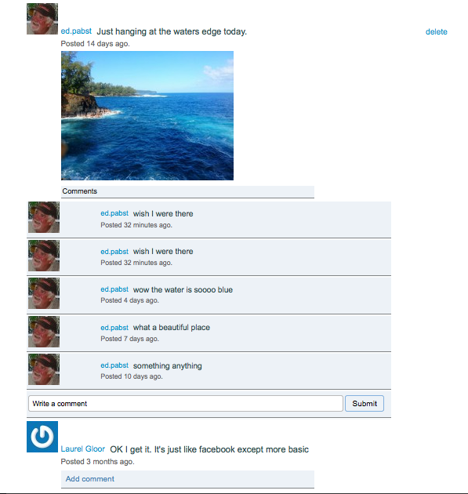

The panel on the right contains your community statistics. Number of farmers that are following you and number of farmers that you are following. You can click on the statictics to view the individual farmers. From there you can choose to “Follow” or “Unfollow” any given farmer.



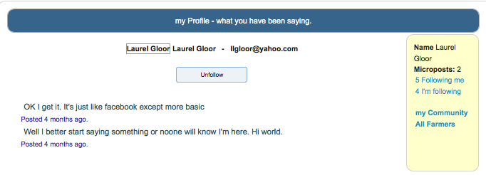

**Appendix – A (Datatypes)**

|  |  |  |
| --- | --- | --- |
| **Data type name** | **Usage Description** | **Is protected?** |
| Activity_type | Type of equipment maintenance activity. In equipment definition. | Yes |
| Application_method | How a supply is applied. In supply definition |  |
| Capacity_uom | Unit of measure of capacity for a storage unit |  |
| Contract_uom | Unit of measure for a sales contract |  |
| Crop_grade | Quality grades for crops. In crop inventory |  |
| Crop_inventory_uom | Unit of measures for crop inventory |  |
| Crop_name | List of various crops. Selected in crop definition |  |
| Crop_type | Types of crops. In crop definition. |  |
| Crop_uom | Unit of measure used for crop harvest. In crop definition. |  |
| Current_state | Current state of a field. In field definition |  |
| Distribution_uom | Unit of measure for supply usage. This is converted from the purchase unit of measure. In supply definition. |  |
| Equipment_category | Category of a piece of equipment. In equipment definition. |  |
| Expense_name | Name of an overhead expense item. In Farm definition. |  |
| Expense_type | Type of expense(cash, non cash overhead, interest) . In Farm definition | Yes |
| Farmjob_sort_sequence | Sort sequence for Farm job reports | Yes |
| Holding_status | State the field is held and managed in. In Field definition. | Yes |
| Invoice_number | Invoice number counter. In invoice creation. | Yes |
| Invoice_sort_sequence | Sort sequence used to print invoices. In Print invoices. |  |
| Invoice_status | Status of the invoice | Yes |
| Invoice_terms | Payment terms for an invoice. |  |
| Job_status | Status of a farm job. (Plan, in process, complete) | Yes |
| Payment_terms | Terms set up for a sales contract. |  |
| Payment_type | Payment type for a sales contract. |  |
| Plan_status | Current status for a Crop plan |  |
| Plan_year | Year of a given Crop plan. |  |
| Po_detail_status | Purchase order line item status. | Yes |
| Po_status | Purchase order status. |  |
| Po_type | Purchase order type. In PO definition. |  |
| Profit_reports | Versions of profitability reports | Yes |
| Reprint | Invoice Reprint state | Yes |
| Scaleticket_number | Scaleticket number counter. In scaleticket definition. | Yes |
| Scaleticket_prefix | Prefix for scaleticket number. |  |
| Security_question | Questions and answers used in case you forget your password | Yes |
| Security_question_0 |  |  |
| Seed_rate_land | Land measure used for seed rates. |  |
| Seed_rate_uom | Unit of measure used for seed rates. In crop definition. |  |
| Ship_status | Shipment status. In shipment definition. | Yes |
| Size_uom | Unit of measure for storage area size. In storage area definition. |  |
| Storage_type | Storage area type. In storage area definition |  |
| Supply_carrier | Carrier type used to disberse a supply. In supply definition. |  |
| Supply_type | Types of supplies. In supply definition. |  |
| Supply_uom | Unit of measure used for supply purchases. In supply definition. |  |
| Task_stage | Stage for a field task. Used in profitability reports. | Yes |
| Task_type | Type of field tasks. In Field task definition. |  |
| Weather_segment | Day segment for farm jobs. In farm job definition. |  |
| Wind_direction | Wind direction for farm jobs. In farm job definition |  |